The temperature readings in Fahrenheit

F𝑎ℎ𝑟𝑒𝑛ℎ𝑒𝑖𝑡=(𝐶𝑒𝑙𝑠𝑖𝑢𝑠 ×9 5 )+32.

Analyze the value of Fahrenheit while temperature is 0, 100, or -40 Celsius

at 0\*c temperature

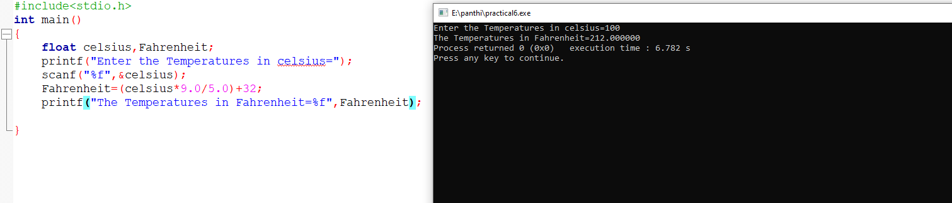

at 100\*c temperature

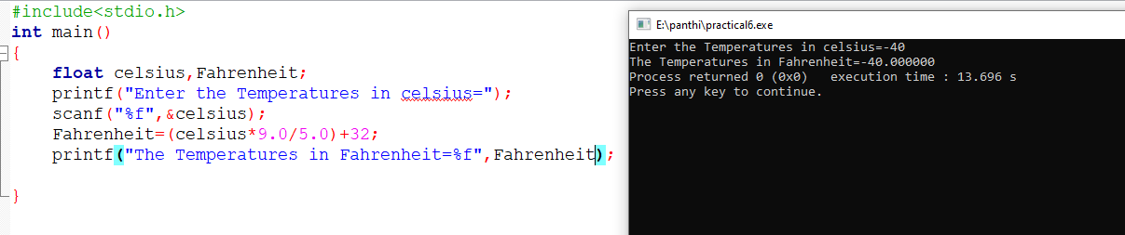

at -40\*c temperature

